UI Screens

0.0
Name:
XML-Name:
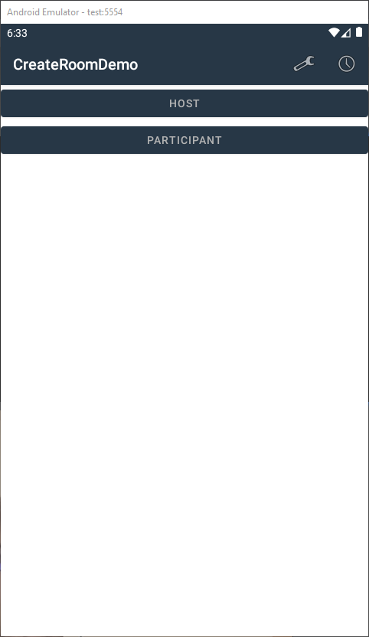

0.1
Name:
XML-Name:
